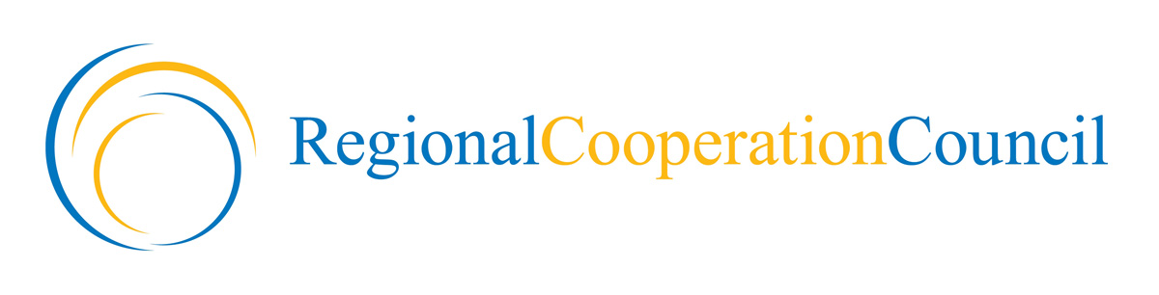 | 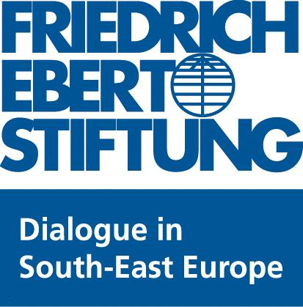 | 
 | 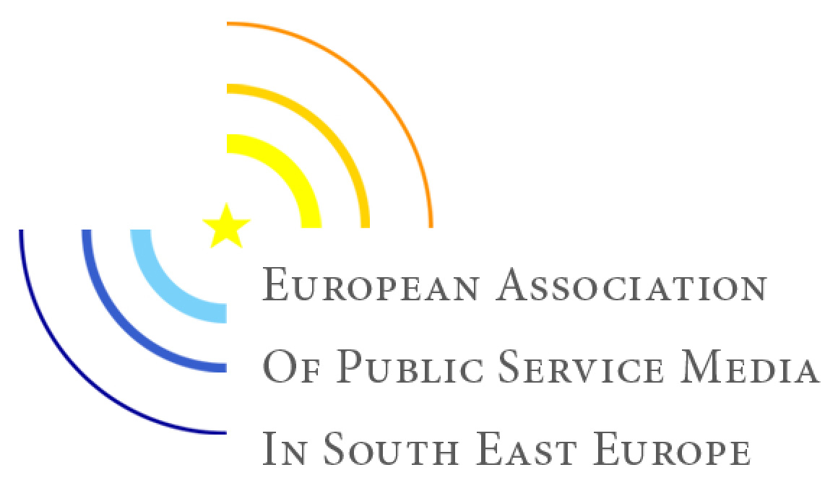

First Academy on Media Law in South East Europe

4 - 8 June 2012

HRT, CROATIAN RADIO TELEVISION - ZAGREB, Prisavavlje 3

AGENDA

4 June 2012, Monday

OPENING

9:30 - 10:00 | Registration of the participants
10:00-10:20 | Opening speeches  - Josip Popovac, President of the European Association of Public Service Media in South East Europe  - Hido Biscevic, Secretary General, Regional Cooperation Council  - Nina Suomalainen, Deputy Head of the OSCE Mission in Bosnia and Herzegovina  Moderator: Dinka Živalj
10:20 – 11.00 | Introductory remarks  - Hendrik Bussiek, Expert  - Barbora Bukovska, Senior Director of Law, ARTICLE 19  - Michael Niebel, Head of Audiovisual and Media Policies Unit, Directorate General for Information Society and Media, European Commission (tbc)  Moderator: Marija Nemcic
11.00– 11.30 | Coffee/Tea Break
11:30 - 13:00 | Warming up  Introduction of the participants and presentation of the objectives of the Academy  Moderator: Boyko Boev
12:30– 14:00 | Lunch Break
14:00 -15:30 | Review of European Court of Human Rights’ judgments concerning media freedom in South East Europe  Presentation: Vuk Cucic, Attorney-at-Law, Lecturer at the University of Belgrade  Moderator: Barbora Bukovska
15:30 – 16:00 | Coffee/Tea Break
16:00 – 17:30 | New media freedom standards: overview of the recent standard setting activities of UN and Council of Europe  Presentation: Boyko Boev, Senior Legal Officer, ARTICLE 19  Moderator: Maja Maricic
17:30 | End of Session
5 June 2012, Tuesday

PUBLIC SERVICE MEDIA REMIT

09.30 – 11:00 | Introduction of standards on the public service media remit  Presentation: Hendrick Bussiek  Moderator: Boris Bergant
11:00 – 11:30 | Coffee break
11:30 – 13:00 | Domestic regulation and policy relating to public service media remit  Presentations by the participants on the regulation in their countries of origin  Moderator: Boris Bergant
13:00 – 14:30 | Lunch
14:30 – 16:00 | Strengthening the pubic service media remit  Group work  The participants will be divided into three groups. The group will discuss the models of regulation of public service media remit in the region and will propose recommendations for legislative reforms based on the best practices  Group leaders: tbc
16:00-16:15 | Coffee break
16:15 – 17:00 | Strengthening the pubic service media remit - continuation  Group work
16:45 –17:30 | Media reform recommendations  Presentations by working groups  Moderator: Boyko Boev
17:30 | End of sessions

6 June 2012, Wednesday

MEDIA PLURALISM

09.30 – 11:00 | Introduction of relevant standards on media pluralism  Presentation:  Elda Brogi, Ph.D.  Researcher - Centre for Media Pluralism, Robert Schuman Centre for Advanced Studies, European University Institute  Moderator:  Dinka Zivalj
11:00 – 11:30 | Coffee break
11:30 – 13:00 | Domestic regulation and policy relating to media pluralism  Presentations by the participants on the regulation in their countries of origin  Moderator:  Dinka Zivalj
13:00 – 14:30 | Lunch
14:30 – 16:00 | Safeguarding media pluralism  Group work  The participants will be divided into three groups. Each group will discuss the models of regulation of public service media remit in the region and will propose recommendations for legislative reforms based on the best practices  Group leaders: tbc
16:00 - 16:15 | Coffee break
16:15 – 17:00 | Safeguarding media pluralism - Continuation  Group work
16:45 –17:30 | Media reform recommendations  Presentations by working groups  Moderator: Boyko Boev
17:30 | End of the sessions
20:00 | INVITATION ON THE CONCERT OF JAZZ ORCHESTRA HRT

7 June 2012, Thursday

MEDIA LAW AND RESPONSIBILITY
09.30 – 11:00 | Introduction of relevant standards concerning media responsibility  Presentation: Alexander Kashamov, Attorney-at-Law  Head of Legal Team, Access to Information Programme, Bulgaria  Moderator: Tanja Topic
11:00 – 11:30 | Coffee break
11:30 – 13:00 | Domestic regulation and policy relating to defamation, the right to reply and the protection of journalistic source  Presentations by the participants on the regulation in their countries of origin  Moderator: Maja Maricic
13:00 – 14:30 | Lunch
14:30 – 16:00 | Improving the regulation on defamation, the right to reply and the protection of journalistic sources  Group work  The participants will be divided into three groups. Each group will discuss the models of regulation of public service media remit in the region and will propose recommendations for legislative reforms based on the best practices  Group leaders: tbc
16:00-16:15 | Coffee break
16:15 – 17:00 | Improving the regulation on defamation, the right to reply and the protection of journalistic sources - Continuation  Group work
16:45 –17:30 | Media reform recommendations  Presentations by working groups  Moderator: Boyko Boev
17:30 | End of the sessions
19:00 | OFFICIAL DINNER

8 June 2012, Friday

Closing

9:30 - 10:30 | Moot Courts as a Means of Media Law and Policy Training  Presentation: Vuk Cucic, lecturer at the University of Belgrade  Moderator: Maja Maricic
10:30-11:00 | Importance of media law in EU enlargement context  Presentation: Andris Kesteris, Principal Advisor on Civil Society and Inter-institutional Relations, Directorate General for Enlargement, European Commission  Moderator: Dinka Zivalj
11.00– 11.30 | Coffee/Tea Break
11:30 - 13:00 | Closing Session/ Wrap up  Moderator: Marija Nemcic
12:30– 14:00 | Lunch Break
 | DEPARTURE

