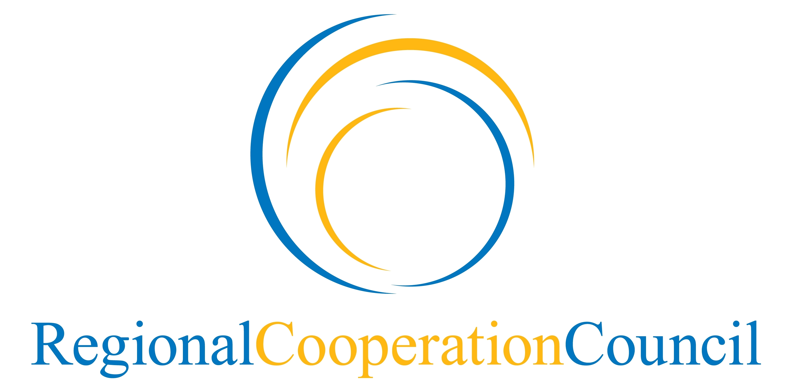

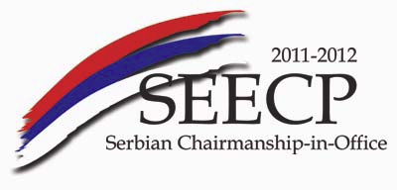

Regional Cooperation Council (RCC) Annual Meeting
13 June 2012, Belgrade

Draft Agenda

- Adoption of the Agenda

- Introductory remarks by the Minister of Foreign Affairs of the Republic of Serbia in capacity of Chairmanship-in-Office of the South East Europe Cooperation Process and by the Secretary General of the Regional Cooperation Council (RCC)

- Annual Report of the Secretary General of the RCC on regional cooperation in South East Europe in the period 12 May 2011–15 May 2012 - presentation and endorsement

- Presentation of the RCC Secretariat’s Self-assessment Report on the First year of the implementation of the RCC Strategy and Work Programme 2011-2013

- Endorsement of the nomination proposal for the Secretary General of the RCC

- Any other business

