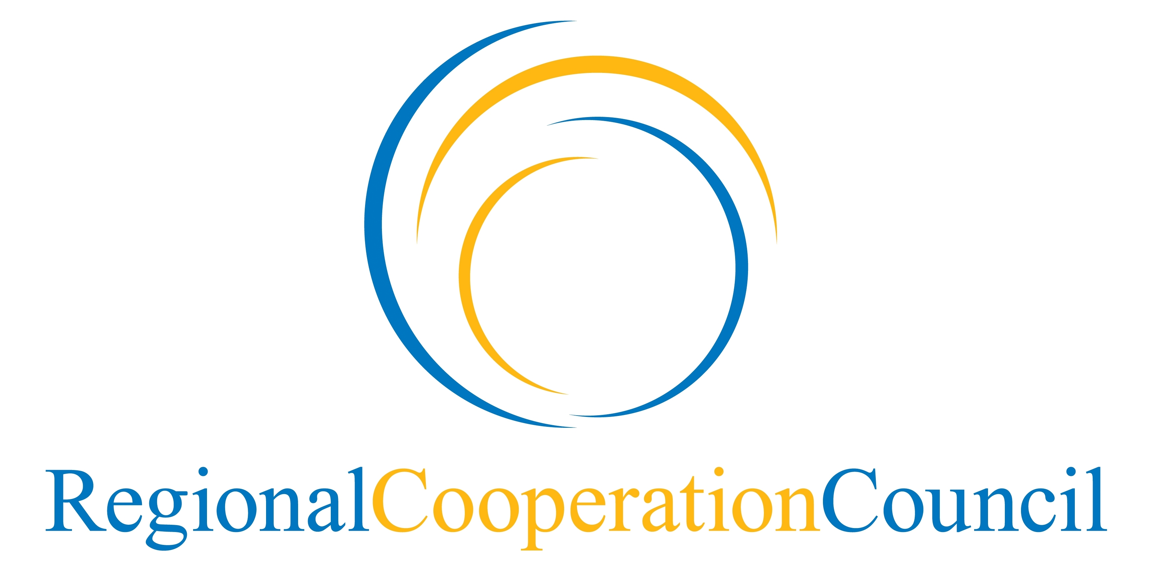 | 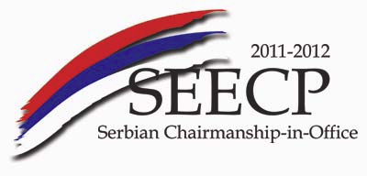

Regional Cooperation Council (RCC) Annual Meeting
13 June 2012, Belgrade

List of participants

ALBANIA

Mr. Genci Mucaj, Director General, RCC National Coordinator, Ministry of Foreign Affairs

AUSTRIA

Mr. Johannes Eigner, Head of Department, Deputy Director General for Economic and European Affairs, RCC National Coordinator, Federal Ministry for European and International Affairs

BOSNIA AND HERZEGOVINA

Ambassador Dragan Božanić, RCC National Coordinator, Ministry of Foreign Affairs

BULGARIA

Mr. Alexander Bakalov, Minister Plenipotentiary, Ministry of Foreign Affairs

CANADA

COUNCIL OF EUROPE

Ms. Nadia Cuk, Deputy Head of Office in Belgrade

COUNCIL OF EUROPE DEVELOPMENT BANK

Mr. Luca Schio, Head of International Relations

CROATIA

CZECH REPUBLIC

H.E. Ms. Hana Hubáčková, Ambassador of the Czech Republic to Serbia and Montenegro in Belgrade

DENMARK

EUROPEAN BANK FOR RECONSTRUCTION AND DEVELOPMENT

EUROPEAN INVESTMENT BANK

EUROPEAN UNION

Mr. Yngve Engström, Head of Unit, DG Enlargement, European Commission
Ms. Yolanda Valassopoulou, Policy Officer, DG Enlargement, European Commission

GENERAL SECRETARIAT OF THE COUNCIL OF THE EUROPEAN UNION

EUROPEAN PARLIAMENT

FEDERAL REPUBLIC OF GERMANY

Mr. Nikolaus Graf Lambsdorff, Ambassador, RCC National Coordinator, Ministry of Foreign Affairs
Mr. Georg Hagl, Desk Officer, Ministry of Foreign Affairs

FINLAND

Ms. Katariina Niemenmaa, Counsellor, RCC National Coordinator, Ministry of Foreign Affairs

FRANCE

GREECE

Ambassador Maria Louisa Marinakis, RCC National Coordinator, Ministry of Foreign Affairs
Ambassador George Avgoustis, Head of Southeast Europe Directorate, Ministry of Foreign Affairs

HUNGARY

H.E. Mr. Oszkar Nikowitz, Ambassador of Hungary to Serbia
Ms. Mira Vuity, Third Secretary, Hungarian Embassy in Belgrade

INTERNATIONAL ORGANIZATION FOR MIGRATION

IRELAND

ITALY

Mr. Piero Cristoforo Sardi, Deputy Chief of Mission, Embassy of the Republic of Italy
Mr. Paolo Toschi, First Secretary, Embassy of the Republic of Italy

KOSOVO*

Mr. Edon Cana, RCC National Coordinator

LATVIA

MOLDOVA

Mr. Alexei Nistrean, Head of Directorate for Regional Cooperation, General Department for European Integration, Ministry of Foreign Affairs and European Integration

*This designation is without prejudice to positions on status, and is in line with UNSC 1244 and the ICJ Opinion on the Kosovo declaration of independence.
MONTENEGRO

Ambassador Zoran Janković, General Director for Multilateral Affairs and Regional Cooperation, RCC National Coordinator, Ministry of Foreign Affairs and European Integration

NORTH ATLANTIC TREATY ORGANISATION

NORWAY

Mr. Jens Grøndahl, Assistant Director General, RCC National Coordinator, Ministry of Foreign Affairs

ORGANISATION FOR ECONOMIC CO-OPERATION AND DEVELOPMENT

Mr. Milan Konopek, Economist and Project Manager, Western Balkans Regional Competitiveness Initiative

ORGANIZATION FOR SECURITY AND CO-OPERATION IN EUROPE

Ambassador Dimitrios Kypreos, Head of OSCE Mission in Belgrade

POLAND

Mr. Paweł Czerwiński, Deputy Head of Mission, Embassy in Belgrade

ROMANIA

Mr. Stefan Tinca, Genral Director, Department of Regional Affairs, Ministry of Foreign Affairs
Ms. Georgiana Sisilica, Second Secretary, Department for Western Balkans and Regional Cooperation, Ministry of Foreign Affairs

SLOVAKIA

H.E. Mr. Ján Varšo, Ambassador of the Slovak Republic in Belgrade

SLOVENIA

Mr. Mitja Močnik, Minister Plenipotentiary, RCC National Coordinator, Ministry of Foreign Affairs
SOUTHEAST EUROPEAN CO-OPERATIVE INITIATIVE

SPAIN

SWEDEN

Mr. Ronnie Nilsson, RCC National Coordinator, Ministry of Foreign Affairs

SWITZERLAND

Mr. Raphael Naegeli, RCC National Coordinator, Federal Department of Foreign Affairs
Mr. Jean-Luc Oesch, Deputy Head of Mission, Swiss Embassy in Belgrade

THE FORMER YUGOSLAV REPUBLIC OF MACEDONIA

Mr. Toni Pavloski, Deputy Head of Department for EU Negotiations, Ministry of Foreign Affairs

TURKEY

Ambassador Hakan Okçal, Director General for Balkans and Central Europe, Ministry of Foreign Affairs
Mr. Murat Karagöz, Deputy Director General for Balkans and Central Europe, Ministry of Foreign Affairs
Ms. Gülce Kumrulu, Head of Section in the Deputy Directorate General for Balkans and Central Europe, Ministry of Foreign Affairs

UNITED KINGDOM

Mr. James Moor, Head of Political Section, Embassy of the United Kingdom in Belgrade
Ms. Louis Leighton, Desk Office for Serbia and Montenegro, Western Balkans and Enlargement Department, Embassy of the United Kingdom in Belgrade

UNITED NATIONS

Mr. William Infante, Resident Coordinator, UN Office in Belgrade
Ms. Borka Jeremić, Coordination Officer, UN Office in Belgrade

UNITED NATIONS ECONOMIC COMISSION FOR EUROPE

UNITED NATIONS DEVELOPMENT PROGRAMME

UNITED NATIONS INTERIM ADMINISTRATION MISSION IN KOSOVO (UNMIK) ON BEHALF OF KOSOVO IN ACCORDANCE WITH UNITED NATIONS SECURITY COUNCIL RESOLUTION 1244

UNITED STATES OF AMERICA

Mr. Raffi Gregorian, RCC National Coordinator, Department of State
Ms. Judith K. Lepuschitz, Political Officer, U.S. Embassy in Belgrade
Ms. Erin Kotheimer, Deputy Economic Counselor, U.S. Embassy in Sarajevo

WORLD BANK

Ms. Jane Armitage, Country Director and Regional Coordinator, Southeast Europe

ADRIATIC IONIAN INITIATIVE

ORGANIZATION OF THE BLACK SEA ECONOMIC COOPERATION

Ambassador Leonidas Chrysanthopoulos, Secretary General

CENTRAL EUROPEAN INITIATIVE

Mr. Zoran Jovanović, Deputy Secretary General
Ms. Maja Vitaljić, Project Officer, CEI Twinning Unit (office in Sarajevo)

REGIONAL COOPERATION COUNCIL (RCC) SECRETARIAT

SERBIA/ SEECP C-i-O

