ACTION PLAN

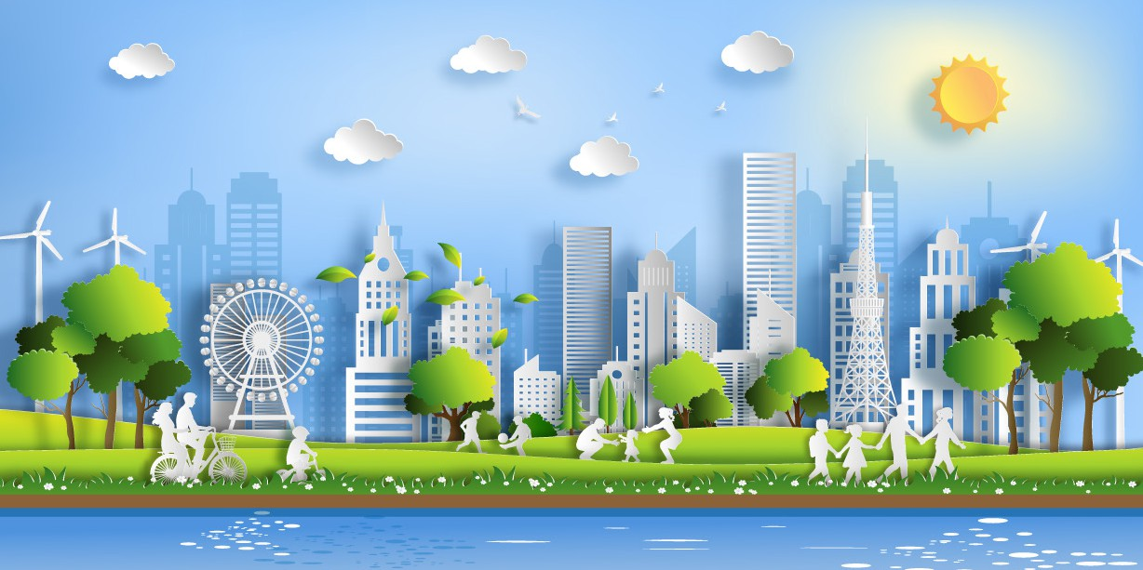

Co-funded by the European Union

**FOR THE IMPLEMENTATION OF THE SOFIA DECLARATION ON THE GREEN AGENDA FOR THE WESTERN BALKANS 2021.-2030.**

**REVISION**

**CIRCULAR ECONOMY**

|  |  |  |  |
| --- | --- | --- | --- |
| **Action** | **The main regional coordinator(s)** | **Indicative timeframe** | **Comment** |
| 29. Improve sustainability of primary production of raw materials. | RCC | 2030. | Continuous improvement by 2030. |
| 30. Apply an industrial ecosystem approach to attain environmentally sustainable, balanced economic recovery. | RCC | 2025. | Through integration of objectives of the new Industrial Strategy for Europe. |
| 31. Develop circular economy strategies looking at the entire lifecycle of products. | RCC | 2023. | Economy-wide strategies to be prepared by the end of 2023;  Western Balkan economies are developing/ have developed Circular Economy Roadmap. |
| 32. Make further progress in the construction and maintenance of waste management infrastructure for cities and regions. | RCC | 2025. | Achieved progress to be reported by 2025; Continuous improvement by 2030. |
| 33. Design and implement consumer-targeted initiatives to raise awareness of citizens on waste prevention, separate collection and sustainable consumption. | RCC | 2022. | A regional campaign to be launched by RCC. |
| 34. Conclude and implement a regional agreement on the prevention of plastic pollution, including specifically addressing the priority issue of marine litter. | EPPA, RCC | 2022. | EPPA can start the process of developing a regional agreement on marine litter, but due to the limited timeframe of the project (until Sept 2022.), it will most probably not be able to see its finalisation;  Link with Actions 43. and 52. |
| 35. Further implement Smart Specialisation Strategies, place-based, innovation-led transformation agendas for sustainability. | RCC | 2024. | Link with Common Regional Market (CRM) initiative. |

# MONITORING SYSTEM

**INDICATORS**

#### No. Indicator Data source

1. Domestic material consumption per capita. [http://appsso.eurostat.ec.europa.eu/nui/show.do?dataset=t2020_rl110&lang=en](http://appsso.eurostat.ec.europa.eu/nui/show.do?dataset=t2020_rl110&lang=en%20) Statistical Offices.

**Circular Economy**

1. Domestic material consumption. [http://appsso.eurostat.ec.europa.eu/nui/show.do?dataset=t2020_rl110&lang=en](http://appsso.eurostat.ec.europa.eu/nui/show.do?dataset=t2020_rl110&lang=en%20) Statistical Offices.
2. Resource productivity. [https://ec.europa.eu/eurostat/databrowser/view/env_ac_rp/default/table?lang=en](https://ec.europa.eu/eurostat/databrowser/view/env_ac_rp/default/table?lang=en%20) Statistical Offices.
3. Generation of waste - Total. [https://ec.europa.eu/eurostat/databrowser/view/env_wasgen/default/table?lang=en](https://ec.europa.eu/eurostat/databrowser/view/env_wasgen/default/table?lang=en%20)

/Environmental Protection Agencies

